JARDIM BOM SUCESSO – LINKS ACESSO 360

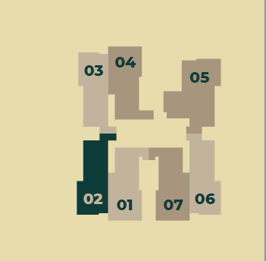

AREA DE LAZER
https://tour360.meupasseiovirtual.com/0203/177272/tourvirtual/index.html

APARTAMENTO FINAL 2
https://tour360.meupasseiovirtual.com/0203/177268/tourvirtual/index.html

APARTAMENTO FINAL 1
https://tour360.meupasseiovirtual.com/0203/177245/tourvirtual/index.html

APARTAMENTO FINAL 7
https://tour360.meupasseiovirtual.com/0203/177261/tourvirtual/index.html

